Converting street lighting to LED with advanced smart controls

Anthony Ogle, Manager Asset Systems

Vimal Vinodan, Street Infrastructure Engineer

City of Ryde NSW Australia

Abstract

City of Ryde has several networks of street lighting on metered supply using Multi Function Poles, totalling over 350 lamps, and the number increasing with each development in the town centres and Macquarie Park CBD.

Although new installations specify LED lamps, the majority use older type lamps, and the city is underway to progressively retrofit all of them with LED with advanced smart controls.

Council has installed a Wireless Access Point that can communicate wirelessly up to 5000 Luminaires within a 10 km radius, covering the whole Ryde LGA. As well as improved lighting functionality and an expected 40% energy saving, the use of the LED lighting with advanced smart controls enables:

• accurate performance reporting

• cheaper maintenance such as through web and ground based diagnostics in daylight

• automated alerts and communication with smartphones

The presentation looks at the success of the first 2 rounds of retrofitting and what was learnt about what the current and potential market has to offer.

**Keywords :** LED

Introduction

Street lighting is an integral part of a modern city's infrastructure for public safety and amenity. LED technology is proving to be superior to older lighting technologies for reducing energy consumption and management of the lighting. Transforming to sophisticated networked smart-controlled LEDs produces major benefits, helping cities save money, reduce CO2 emissions and improve lighting effects efficiency for a better service to the public.

Major cities like Los Angeles, Las Vegas, Austin, Texas etc in United States have realised the benefits for LED conversion with smart controls and deployed LED retrofit programs in the past few years. Through these projects they have saved millions of dollars which is about 40%-60% savings in the energy bills and maintenance cost.

### Ryde’s Program

Council has several geographically separate private street lighting networks around each of its town centres, the largest being around Macquarie Park CBD (which is now the 4th largest CBD in Australia based on floor space, and land coverage). These networks are metered and fully run by Council separate to the 8,000+ lamps in the regular (Ausgrid) network.

These networks in total currently have about 350 lamps on Multi-Function Poles (MFP’s), with more being added as developers upgrade the public domain streetscapes. The potential is over 1,200 lamps.

Council’s aim is to convert the existing lamps to LED with smart controls, and require all new lighting to be installed with similar technology.

As the technology is still relatively new particularly with smart controls, the roll-out is being done over 8-10 years on a self-funding basis. This incremental approach allows Council to evaluate each installation to confirm the benefits, and update successive stages to take advantage of lessons learnt and market offerings. This approach also enables Council to control new developer contributed lighting based on performance specification rather than proprietary products.

### Completed Stages

City of Ryde council began deploying LED Retrofit projects with the smart controls from 2014/2015, with 2 stages completed so far.

*Stage 1 – Meadowbank*

An area near Meadowbank railway station and ferry wharf with up to 30 lamps was selected as it provided several technical challenges that would assist in understanding LED and smart controls, as well as the progressive roll-out process.

The accepted tender involved retrofitting 25 of 250W Metal Halide luminaire with 138W LED Luminaires. Being near the railway high voltage overhead catenary, there was potential for interference for the wireless signals, and dual control through the lighting cabling was provided.

The schematic representation of Councils wireless smart control system is shown below:

Each luminaire has a 7 pin NEMA radio frequency (RF) node in place of the traditional Photo-Electric (PE) Cell, which communicates with the server through a local Wireless Access Point (WAP). The WAP is similar to phone towers and operates best with clear line of sight

Given the local topography and fortunate location of its civic building, Council located a single WAP on the roof that could service several of the town centres for later stages. This WAP can service up to 5000 Luminaires within a 10 km radius.

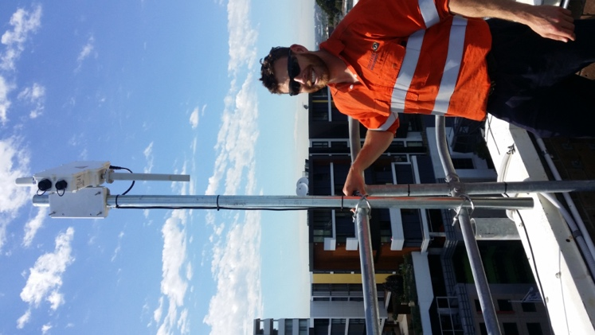 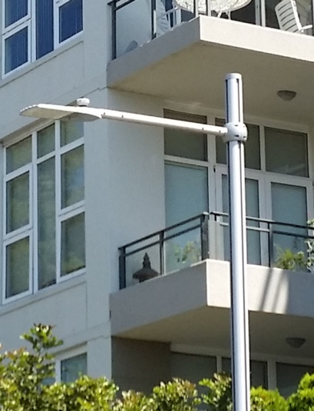

**Pic1: Two-way wireless communication between WAP (on-left) and RF Node attached on LED Luminaire located at 2.5 km from WAP**

*Stage 2 – Top Ryde*

The initial installation of lights near Top Ryde was eight years old having being done as part of the shopping centre re-development. Many of the lamps along the busy State Roads had failed and extremely difficult to access. There were also circuit problems that needed resolving.

This stage replaced 45 Metal Halide Luminaires with LED’s, and allows evaluation and controls specific to lighting for main road vehicle levels as well as local traffic and pedestrians.

The timing of completion in June 2016 fortunately coincided with the changes allowing Council to claim under NSW Energy Saving Scheme.

### Benefits gained from LED lighting with Smart Control System

As Ryde’s LED are on multifunction poles with metered circuits, the energy use before and after conversion is clearly recorded. The demonstrated savings are over 50%

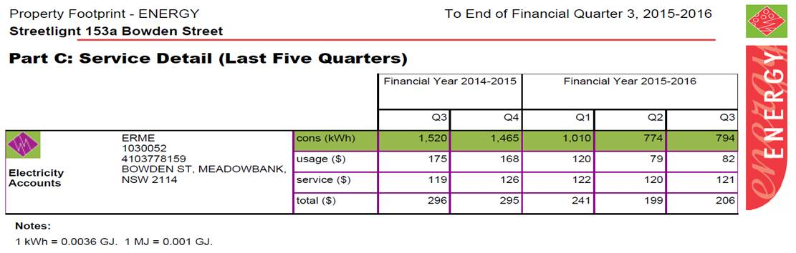

**Pic 2: Example of actual energy saving obtained in a circuit of 6 LED lights as part of Meadowbank Project (Stage one)**

The benefits of smart-controls are:

* Cheaper maintenance through diagnostics web based (on-ground) and daytime inspections rather than night patrols
* Manual and programmed control over the lights to switch On/Off and adjust light levels using smartphones, tablet PCs, Laptops etc.

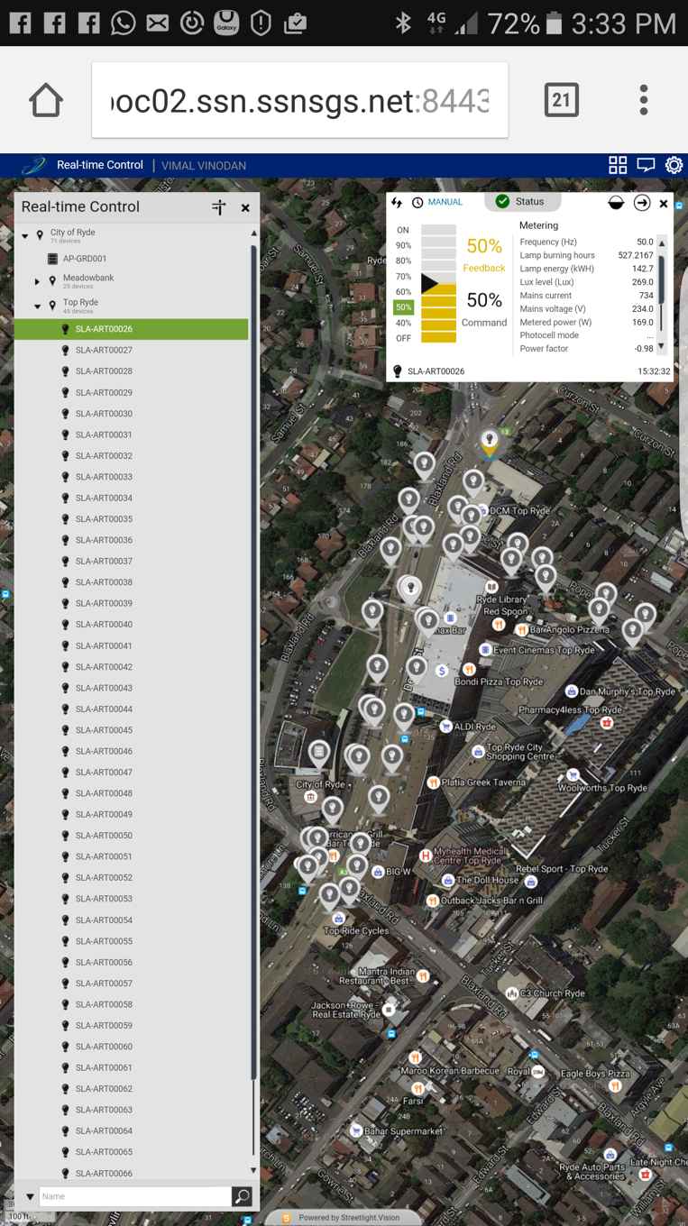

WAP

**Pic 3: Real-time control on the Top Ryde LEDs with smart controls**

* Automated alerts, recording and reports for better maintenance response and management

### Where from here?

Council will continue to roll-out stages of about 50 lights each year. The next stage will be the remainder of the Top Ryde network, and include installing multiple WAP’s on MFP’s as the shopping centre with residential towers on top has wireless signal shadows.

In looking at how to use the controls, it has become clear that the Australian Standard on lighting does not envisage or deal with the issues and potential of controlling variable light levels.

Council will be trialling and evaluating what the controls enable in a structured way to feed these into supplementing or developing an alternative “standard” specific to Local Government street lighting networks.

The initial exploration will be on:

* ‘Time’ based programmed dimming outside of the peak use periods such as early morning
* Motion sensor activated adjustment to light levels
* Measured and assessing actual lighting output over time and against various performance requirements

Conclusion

The expected benefits including 50% energy savings have been clearly achieved, and Council will be continuing with the staged program of converting the remainder of the MFP based lighting network to LED’s with smart controls.

Ryde has valuable experience in the use of the smart control technology that it can share with the industry. It is also positioned as a leader in using modern technology as part of its assets and their management.

Author Biography

|  |  |
| --- | --- |
| j0291984 | Anthony has 35 years experience in state and local government across a broad range of civil, waste, recreation and facilities works and infrastructure, and over 10 years in management roles. In more recent years this has focussed on asset management and its decision making processes, and is now with City of Ryde as Manager Assets Systems  City of Ryde  Operations Centre  1 Constitution Rd, Ryde NSW 2112  [aogle@ryde.nsw.gov.au](mailto:aogle@ryde.nsw.gov.au)  0426 299621 |
| j0291984 | Vimal is a Civil Engineer developing a career in Local Government with a keen interest in Streetscape Civil Infrastructure. He has a Masters in Engineering Management and Masters in Civil and Structural Engineering with Highest Achiever's Award. In his current role he is responsible for managing Council street lighting network.  City of Ryde  Operations Centre  1 Constitution Rd, Ryde NSW 2112  [vvinodan@ryde.nsw.gov.au](mailto:vvinodan@ryde.nsw.gov.au)  0452 0452 82 |